# Complete Example

# Simultaneous Multiple Regression

**Description:**

* Simultaneous multiple linear regression allows you to use several predictors (Xs) to understand a criterion (Y) at once. You use all variables at once (rather than steps) to see how each variable changes Y *while holding the other variables constant.*
* Definitions to remember:
  + b (little b) = Coefficient, this value is the unstandardized slope for your regression equation. For every one point increase in X, you will get b points increase in Y. This score will be based on the scale of the variable you are using to predict.
  + β (beta) = Coefficient, this value is the standardized slope for your regression equation. With one X/predictor beta is equal to Pearson’s r. Since beta is standardized you can use it to compare across predictors at which IV best explained your DV.
  + *R2* = the amount of variance in the DV scores that your IV/predictors account for. This number is effect size for regression equations.
  + *pr* = partial correlation, the variance from only *that IV* over the variance *not accounted for (error)*. Tells you how much variance your variance accounts for when you only look at variance that you can explain. Proportion of variance in Y not explain by other predictors.
* Two questions to answer:
  + Is my overall model significant?
  + Which of my individual predictors are significant?

**Data Set:** data 1.csv

**IV(s):**

* Books – the number of books a person reads.
* Attend – the attendance of a person in a course.

**DV:**

* Grade – final grade in the course.

**Research Question:** Do attendance and books **both** predict overall course grade?

**Power:**

1. Open Gpower!
   1. Test family: F-test
   2. Statistical Test: Linear multiple regression: fixed model, R2 deviation from zero.
      1. We are using multiple regression because we have more than one predictor.
      2. R2 deviation from zero indicates that we are interested in the overall model, rather than asking if the addition of more predictors to previous model are useful.
   3. Estimate an effect size: click determine 🡪 use R square sizes you think might be accurate, remember small, medium, and large estimates from the notes.
   4. Alpha = .05
   5. Power (1-beta .20) = .80
   6. Number of predictors: number of IVs/X variables.
2. Let’s estimate the following:
   1. Small effect size (*R2* = .01)
   2. Number of predictors: 2
3. Says we needed to run 957 people to find a significant effect with a small effect size.

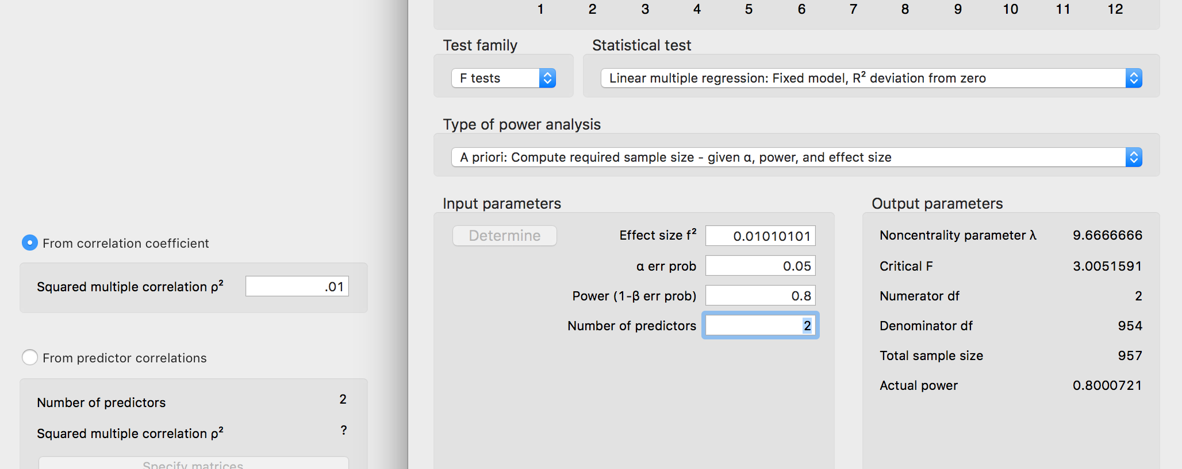

**Results**

The number of books a student read per semester and their overall attendance in the semester was used to predict final course grade. The data were screened for missing data, outliers and regression assumptions. No outliers were found using *z*-scores as a criterion. Linearity, normality, additivity, homogeneity, and homoscedasticity were all met.

The overall regression model was significant, indicating the books and attendance combined predicted final course grade, *F*(2, 37) = 9.06, *p* < .001, *R2*= .33. As students read more books throughout the semester, they were more likely to increase their course grade, *b* = 4.04, *t*(37) = 2.30, *p* = .03, *pr2* = .12. Attendance was also a significant predictor of course grade, so that students who attended class more had higher grades, *b* = 1.28, *t*(37) = 2.19, *p* = .04, *pr2* = .12. See Figure 1 for a representation of the regression equation for this data.

NOTE: you can include b or beta in the write up, just be consistent.

# Results

## Linear Regression

| **Model Summary** | | | | | | | | | | | | | | | | | | | |
| --- | --- | --- | --- | --- | --- | --- | --- | --- | --- | --- | --- | --- | --- | --- | --- | --- | --- | --- | --- |
| **Model** | | **R** | | **R²** | | **Adjusted R²** | | **RMSE** | | **R² Change** | | **F Change** | | **df1** | | **df2** | | **p** | |
| 1 |  | 0.573 |  | 0.329 |  | 0.292 |  | 14.052 |  | 0.329 |  | 9.059 |  | 2 |  | 37 |  | < .001 |  |
|  | | | | | | | | | | | | | | | | | | | |
| *F*(2, 37) = 9.06, *p* < .001, *R²* = .33  Books and attendance significantly predict grade in course. | | | | | | | | | | | | | | | | | | | |

| **ANOVA** | | | | | | | | | | | | | |
| --- | --- | --- | --- | --- | --- | --- | --- | --- | --- | --- | --- | --- | --- |
| **Model** | |  | | **Sum of Squares** | | **df** | | **Mean Square** | | **F** | | **p** | |
| 1 |  | Regression |  | 3578 |  | 2 |  | 1788.8 |  | 9.059 |  | < .001 |  |
|  |  | Residual |  | 7306 |  | 37 |  | 197.5 |  |  |  |  |  |
|  |  | Total |  | 10884 |  | 39 |  |  |  |  |  |  |  |
|  | | | | | | | | | | | | | |

| **Coefficients** | | | | | | | | | | | | | |
| --- | --- | --- | --- | --- | --- | --- | --- | --- | --- | --- | --- | --- | --- |
| **Model** | |  | | **Unstandardized** | | **Standard Error** | | **Standardized** | | **t** | | **p** | |
| 1 |  | intercept |  | 37.379 |  | 7.745 |  |  |  | 4.827 |  | < .001 |  |
|  |  | attend |  | 1.283 |  | 0.587 |  | 0.329 |  | 2.187 |  | 0.035 |  |
|  |  | books |  | 4.037 |  | 1.753 |  | 0.346 |  | 2.303 |  | 0.027 |  |
|  | | | | | | | | | | | | | |
| Attendance, *b* = 1.28, *t*(37) = 2.19, *p* = .04, *pr2* = .12  Books, *b* = 4.04, *t*(37) = 2.30, *p* = .03, *pr2* = .12 | | | | | | | | | | | | | |

| **Part And Partial Correlations** | | | | | | | |
| --- | --- | --- | --- | --- | --- | --- | --- |
| **Model** | |  | | **Partial** | | **Part** | |
| 1 |  | attend |  | 0.338 |  | 0.295 |  |
|  |  | books |  | 0.354 |  | 0.310 |  |
|  | | | | | | | |

| **Casewise Diagnostics** | | | | | | | | | |
| --- | --- | --- | --- | --- | --- | --- | --- | --- | --- |
| **Case Number** | | **Std. Residual** | | **grade** | | **Predicted Value** | | **Residual** | |
| . |  | . |  | . |  | . |  | . |  |
|  | | | | | | | | | |

| **Residuals Statistics** | | | | | | | | | | | |
| --- | --- | --- | --- | --- | --- | --- | --- | --- | --- | --- | --- |
|  | | **Minimum** | | **Maximum** | | **Mean** | | **SD** | | **N** | |
| Predicted Value |  | 45.080 |  | 79.196 |  | 63.550 |  | 9.578 |  | 40 |  |
| Residual |  | -20.802 |  | 32.295 |  | -0.000 |  | 13.687 |  | 40 |  |
| Std. Predicted Value |  | -1.928 |  | 1.634 |  | 0.000 |  | 1.000 |  | 40 |  |
| Std. Residual |  | -1.578 |  | 2.329 |  | -0.003 |  | 1.010 |  | 40 |  |
|  | | | | | | | | | | | |

### Residuals vs. Predicted

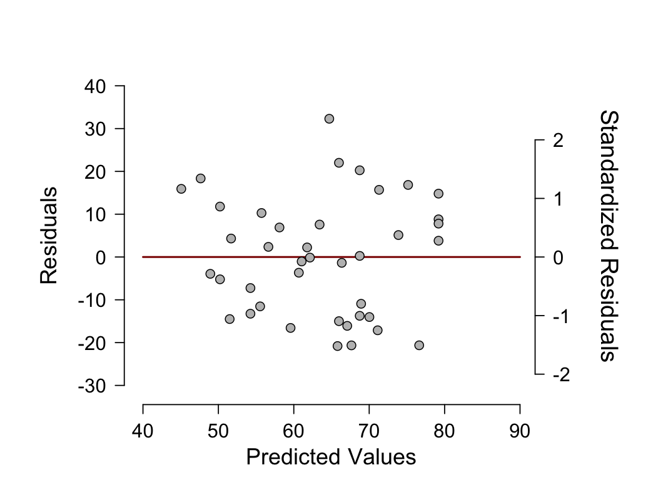

### Standardized Residuals Histogram

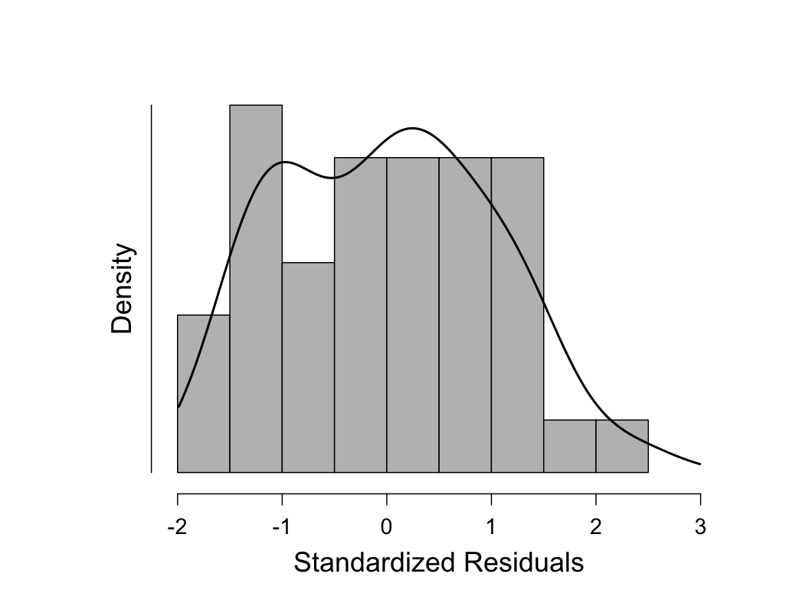

### Q-Q Plot Standardized Residuals

